+
227 B South Garden Ave.
Newport WA, 99156
Phone: 509-447-2402
Email: noxweedinfo@pendoreille.org
www.pendoreilleco.org/weedboard

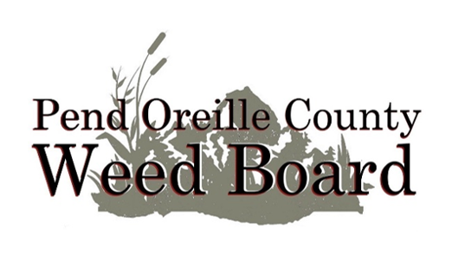

Agenda
Pend Oreille County Noxious Weed Control Board
Wednesday, April 10, 2024
Weed Board Office, 227-B South Garden Avenue
2:00 PM

Public Comment opens at 2:00 p.m.

Open 2024 Herbicide hearing at 2:15 pm

Consent Items
Approve travel expenses for this meeting
Approve March 11, 2024, Regular Meeting Minutes

New Business
- Herbicide Hearing
- Review and discuss with the Board the March revenue & expense reports (attachment A 1-2). Approve March expenses
- Employee updates and monthly reports (attachments B 1-3)
- Coordinator reports & updates: Staffing update, grants & agreements
- State Weed Board Coordinator’s Conference Report & Western Aquatic Plant Management Society Conference Report
- Discuss RFPs for Aquatic Contractors May
- Open Discussion

