+
227 B South Garden Ave.
Newport WA, 99156
Phone: 509-447-2402
Email: noxweedinfo@pendoreille.org
www.pendoreilleco.org/weedboard

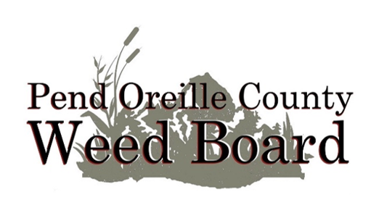

Agenda
Pend Oreille County Noxious Weed Control Board
Monday, March 11, 2024
Weed Board Office, 227-B South Garden Avenue
2:00 PM

Public Comment opens at 2:00 p.m.

Consent Items
Approve travel expenses for this meeting
Approve February 14, 2024, Regular Meeting Minutes

New Business
- Review and discuss with the Board the February revenue & expense reports (attachment A 1-2). Approve February expenses
- Employee updates and monthly reports (attachments B 1-3)
- Coordinator reports & updates: Staffing update, grants & agreements
- Review Seattle City Lights Agreement (Attachment C)
- Review Annual Ad (attachment D)

Open Discussion
- Discuss moving April Board Meeting date to the following week (15 – 19)
- Discuss Calibration Workshop date for end of April

Old Business
- Annual Report Review

